PURCHASE ORDER ENTRY
1.
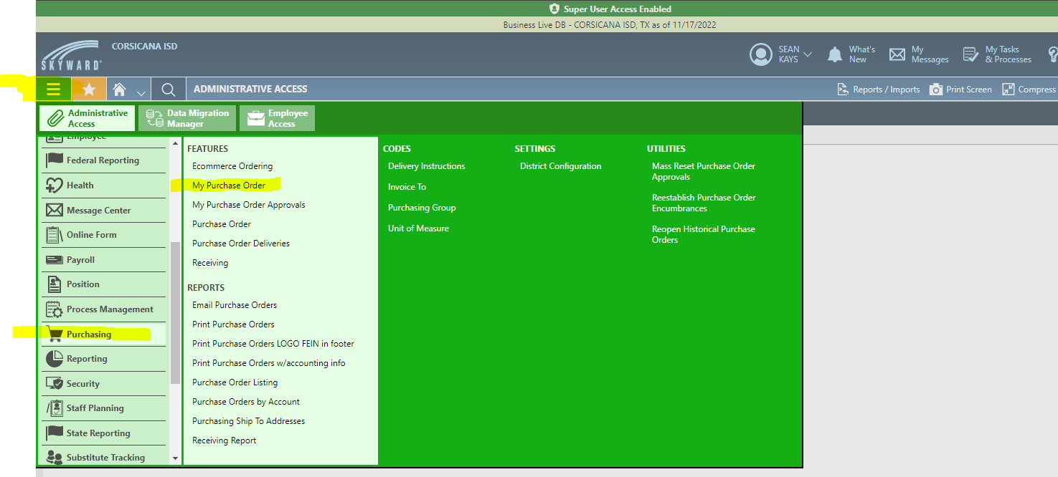
2. 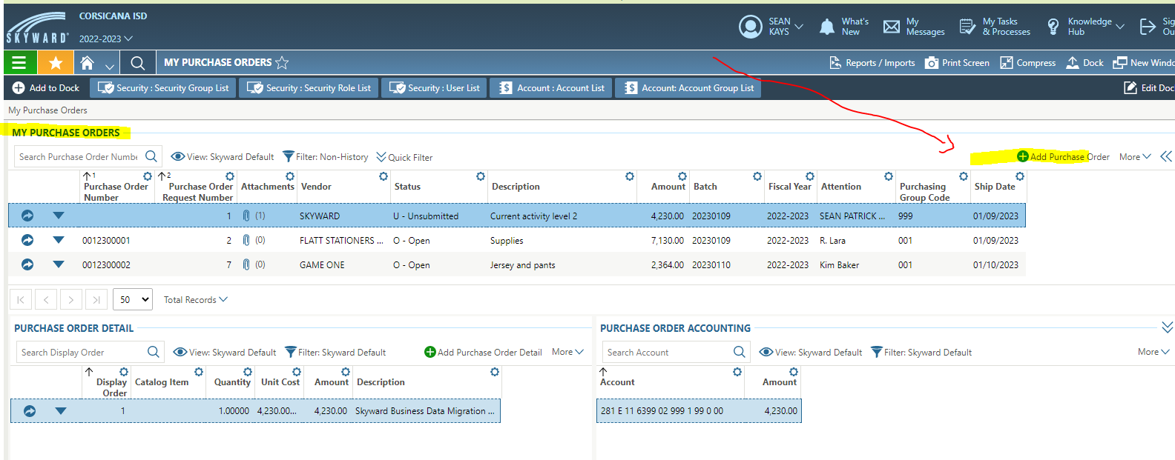
3. You can add attachments if you like (shopping cart with items, quote, etc.). Make the batch number Monday’s date of the week you’re entering it. For example, all POs this week will have a batch date of 1/9/2022. Skip blanket, shop online, commodity, due date, contract, and ship date. When finished, hit Save and Add Detail.
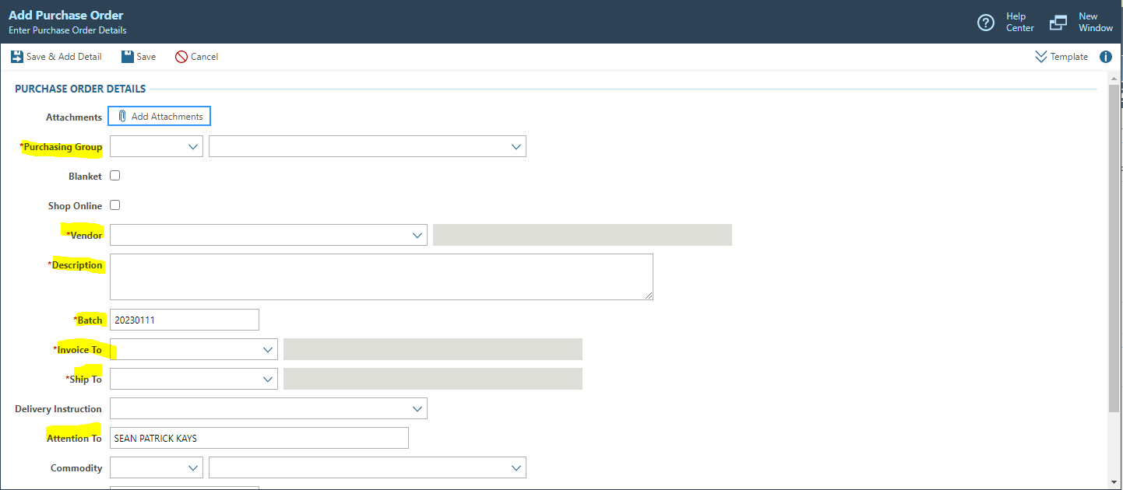
4. After hitting Save and Add Detail, you’ll enter specifics about the items you are purchasing. If you have multiple items, you will add one item on this page and then hit Save and Add Another. If you have more than 3 items, you can attach the quote/shopping cart and in the description type “See attached”. If you do this, your quantity would be 1 and the unit cost will be the total of all the purchases. Be sure to still scan and attach the quote so that Mr. Andrews can send the order off to the vendor. When completely finished, hit Save and Submit. See below for highlighted areas that concern you on this screen.
